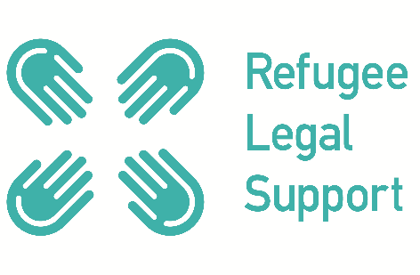

VOLUNTEER APPLICATION FORM

Post applied for:

RLS-Athens  ☐ Volunteer Lawyer  ☐ Legal (non-lawyer) volunteer | RLS United Kingdom  ☐ Volunteer Lawyer  ☐ Legal (non-lawyer) volunteer  ☐ Non-legal volunteer

Personal Details
Name (Last, First):

Address:

Telephone: | Email:
Residency status in Europe: ☐ British ☐ EU national ☐ Other form of right to reside in UK/ EU (please specify)

Languages (including level of written / spoken fluency – native / fluent / intermediate / beginner)

Legal Qualifications:
☐ UK Barrister ☐ UK Solicitor ☐ UK OISC Level 3 ☐ UK Law Society Level 2
☐ Other legal qualifications (please specify country, membership with bar / law society):

Valid Practising / Qualification Certificate? ☐ Yes ☐ No

Date of expiry:

Please confirm you will be able and willing to produce a copy of your certificate on request. ☐

For Lawyer Volunteer Only: Please briefly describe your experience in immigration and asylum work in the UK or elsewhere, whether in a legal or non-legal capacity. In particular please provide no. of years in asylum law practice, no. of cases in asylum law practice and other relevant experience in dealing with migrant affairs.

Other qualifications (including past volunteering and work experience, if applicable): (We are happy to receive curriculum vitaes as attachments to this application form.)

Current / Most recent place of employment:

Professional address:

Contact Person:

Brief reasons why you believe you will be suited for volunteering with RLS: (Feel free to use one A4 continuation sheet.)

Do you have any unspent criminal convictions? ☐ Yes ☐ No
If yes, please supply details including dates:

Please confirm you have read our Safeguarding Policy: ☐
Please confirm you have read our Confidentiality and Data Protection Policy: ☐

Reference: Please nominate someone who is not a family member or friend and who is familiar with your experience in relation to the role you are applying for.)

Name:

Professional relationship to volunteer:

Email:

Telephone no:

Please confirm the referee’s preferred mode of contact:

How did you find out about RLS?
☐ RLS Website ☐ Twitter ☐ Facebook ☐ ILPA ☐ Refugee Legal Group UK googlegroup ☐ Khora Community Centre ☐ Other (please specify):

Emergency Contact
Name:

Address:

Telephone:

Email:

Relationship to volunteer:

Equal Opportunities Monitoring Form
What is your gender?

☐ Female ☐ Male ☐ Prefer not to say

Disability

The UK Equality Act 2010 generally defines a disabled person as someone who has a mental or physical impairment that has a substantial and long-term adverse effect on the person’s ability to carry out normal day-to-day activities.

Do you consider yourself to have a disability according to the definition above?
☐ Yes ☐ No ☐ Prefer not to say

Are your day-to-day activities limited because of a health problem or disability which has lasted, or is expected to last, at least 12 months?

☐ Yes ☐ No ☐ Prefer not to say

FOR OFFICE USE
Signed Volunteer Agreement and Confidentiality form? ☐ Yes ☐ No
Signed Confirmation to abide by Safeguarding Policy? ☐ Yes ☐ No

